Program 2

Keyboard Interface

Circle

Input:

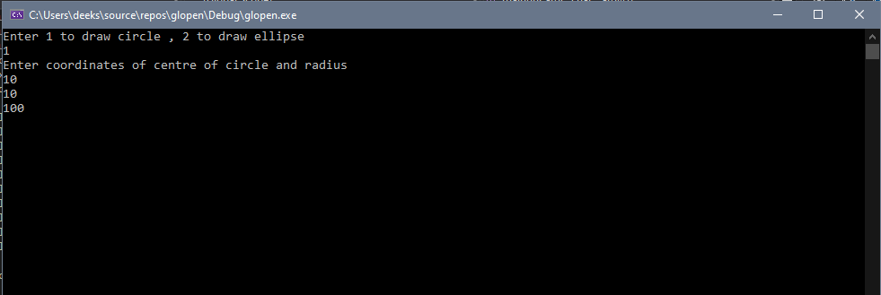

Output:

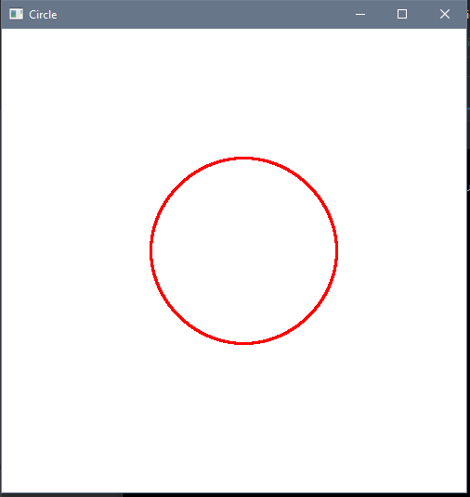

Ellipse

Input:

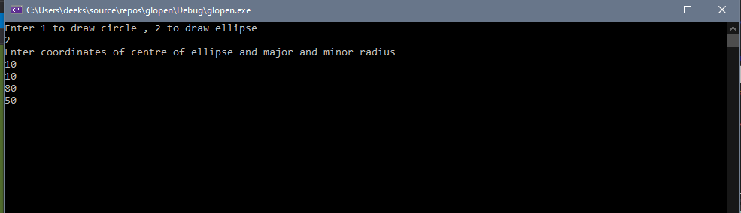

Output:

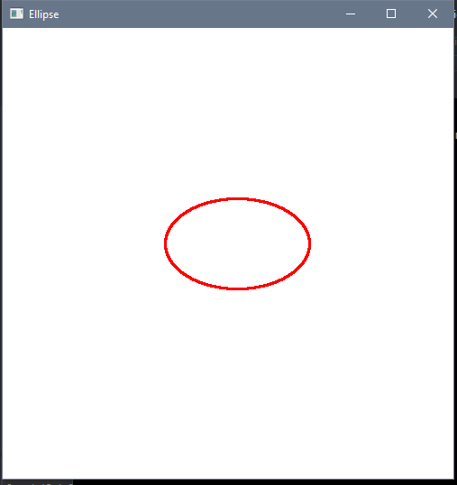

Mouse Interface

Circle

Input: 2 clicks – 1st click for centre; 2nd click for radius.

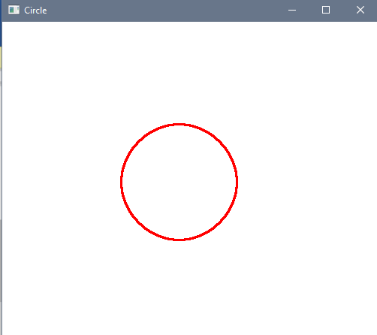

Ellipse

Input: 3 clicks – 1st click for centre of ellipse; 2nd click for major axis; 3rd click for minor axis.

